**How to display and select images from SDCard**

1. **Introduction**

This tutorial will help you know how to display an image chosen UI of images available in SDCard and let users select one of them.

1. **When should you apply this?**

You should apply this when you want to get images in your phone.

1. **Advantages**

User friendly and good feature.

1. **Disadvantages**

Android phone must have SDCard.

1. **Requirement**

Eclipse and emulator or real phone.

1. **Steps and Screen shots**

* First, you need to get image from SDCard. I will crop image in sdcard assuming I already know image name and its location.
* In this code below, I will get image in mnt/sdcard/Nish. mnt/sdcard is the sdcard location in DDMS and Nish is my own folder that I created. Then I get an image named temp.jpg

**private** Uri mImageCaptureUri;

**private** **static** **final** **int** *PICK_FROM_FILE* = 3;

**public** **void** onCreate(Bundle savedInstanceState) {

**super**.onCreate(savedInstanceState);

Intent intent = **new** Intent();

intent.setType("image/*");

intent.setAction(Intent.*ACTION_GET_CONTENT*);

startActivityForResult(

Intent.*createChooser*(intent, "Complete action using"),

*PICK_FROM_FILE*);

}

* The last line in the above code will call a method named onActivityResult() which I use to deal with chosen image as I have its URI: mImageCaptureUri in the code below.

**protected** **void** onActivityResult(**int** requestCode, **int** resultCode, Intent data) {

**switch** (requestCode) {

**case** *PICK_FROM_FILE*:

mImageCaptureUri = data.getData();

//deal with chosen image.

**break**;

}

}

* Here is an image chosen UI

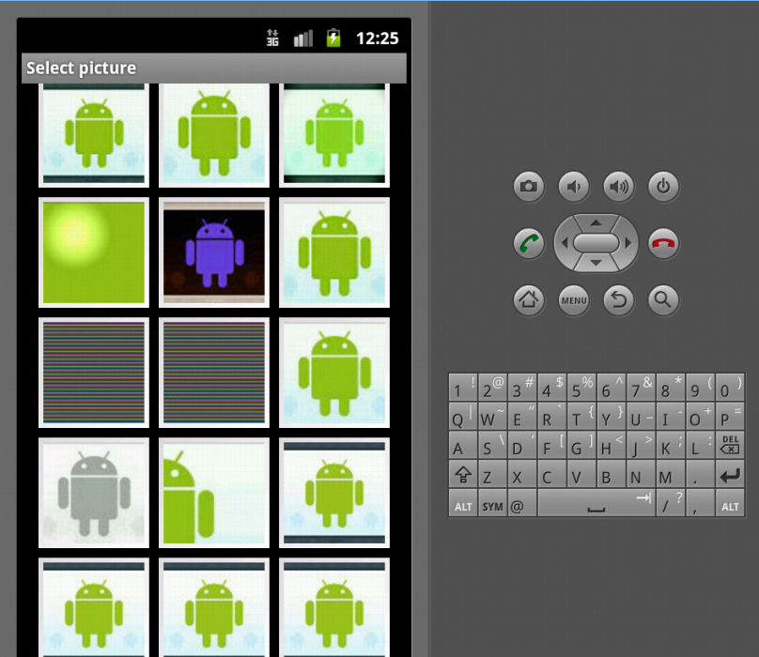

1. **Reference**

<https://github.com/lorensiuswlt/AndroidImageCrop>

Contact me if you have any question: bachxvu@gmail.com